Lab-1 Report
Introduction to IC circuits

Aim: Study of Digital ICs and identification of ICs by analysis of it’s behaviour when subjected to different inputs.

Components used:

- 7404(NOT)
- 7408(AND)
- 7432(OR)
- 7486(XOR)
- 1KΩ resistor array
- DIP switches
- LED displays
- Breadboard
- Power supply

Design Procedure:

- Implemented each of the 7 gates using the relevant ICs required
- Usage of DIP switches for the input signals where ON position indicates 1 and OFF position indicates 0 & output from the gate has been connected to an LED display for identification of output.
- Logic tables of IC’s :

NOT GATE

INPUT | OUTPUT
0 | 1
1 | 0

AND GATE

INPUT 1 | INPUT 2 | OUTPUT
0 | 0 | 0
0 | 1 | 0
1 | 0 | 0
1 | 1 | 1

OR GATE

INPUT 1 | INPUT 2 | OUTPUT
0 | 0 | 0
0 | 1 | 1
1 | 0 | 1
1 | 1 | 1

XOR GATE

INPUT 1 | INPUT 2 | OUTPUT
0 | 0 | 0
0 | 1 | 1
1 | 0 | 1
1 | 1 | 0

NAND GATE

INPUT 1 | INPUT 2 | OUTPUT
0 | 0 | 1
0 | 1 | 1
1 | 0 | 1
1 | 1 | 0

NOR GATE

INPUT 1 | INPUT 2 | OUTPUT
0 | 0 | 1
0 | 1 | 0
1 | 0 | 0
1 | 1 | 0

XNOR GATE

INPUT 1 | INPUT 2 | OUTPUT
0 | 0 | 1
0 | 1 | 0
1 | 0 | 0
1 | 1 | 1

- Circuit diagrams for these circuits will look like:

And, Or and Xor gates connection:-

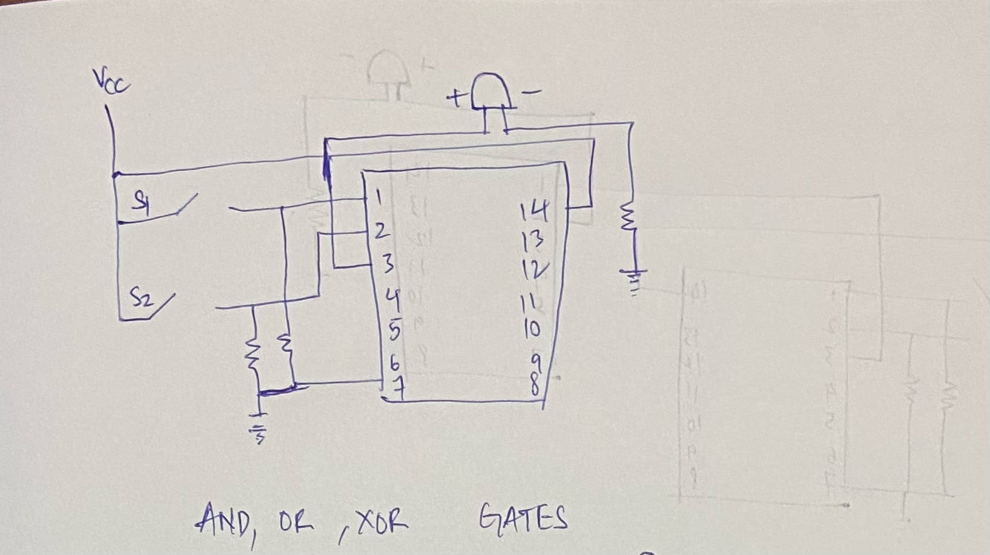

Not gate connection:-
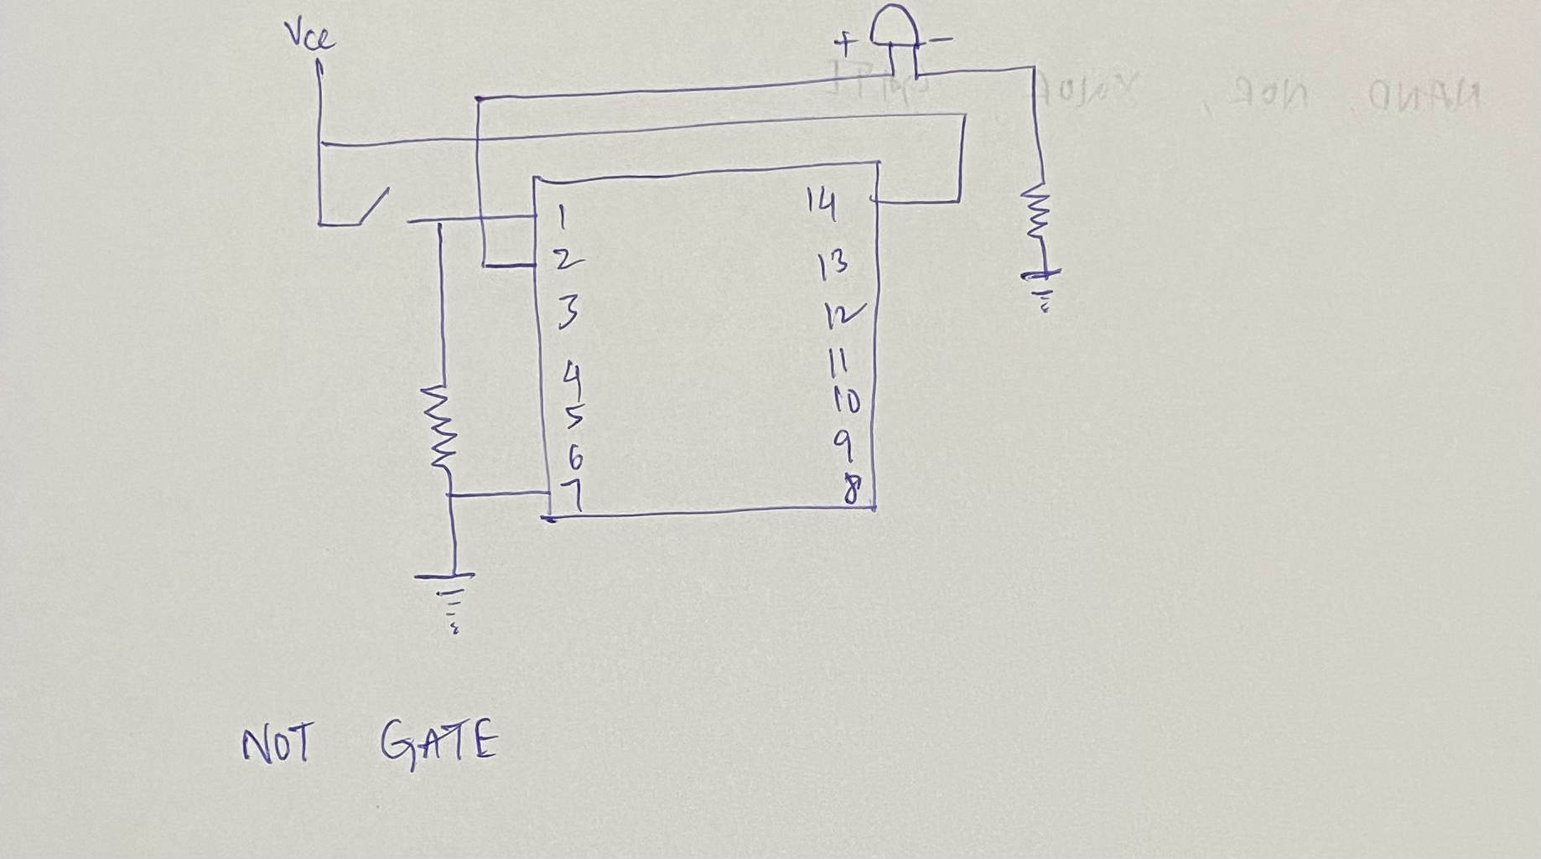

Nand, Nor, Xnor gates connections:-

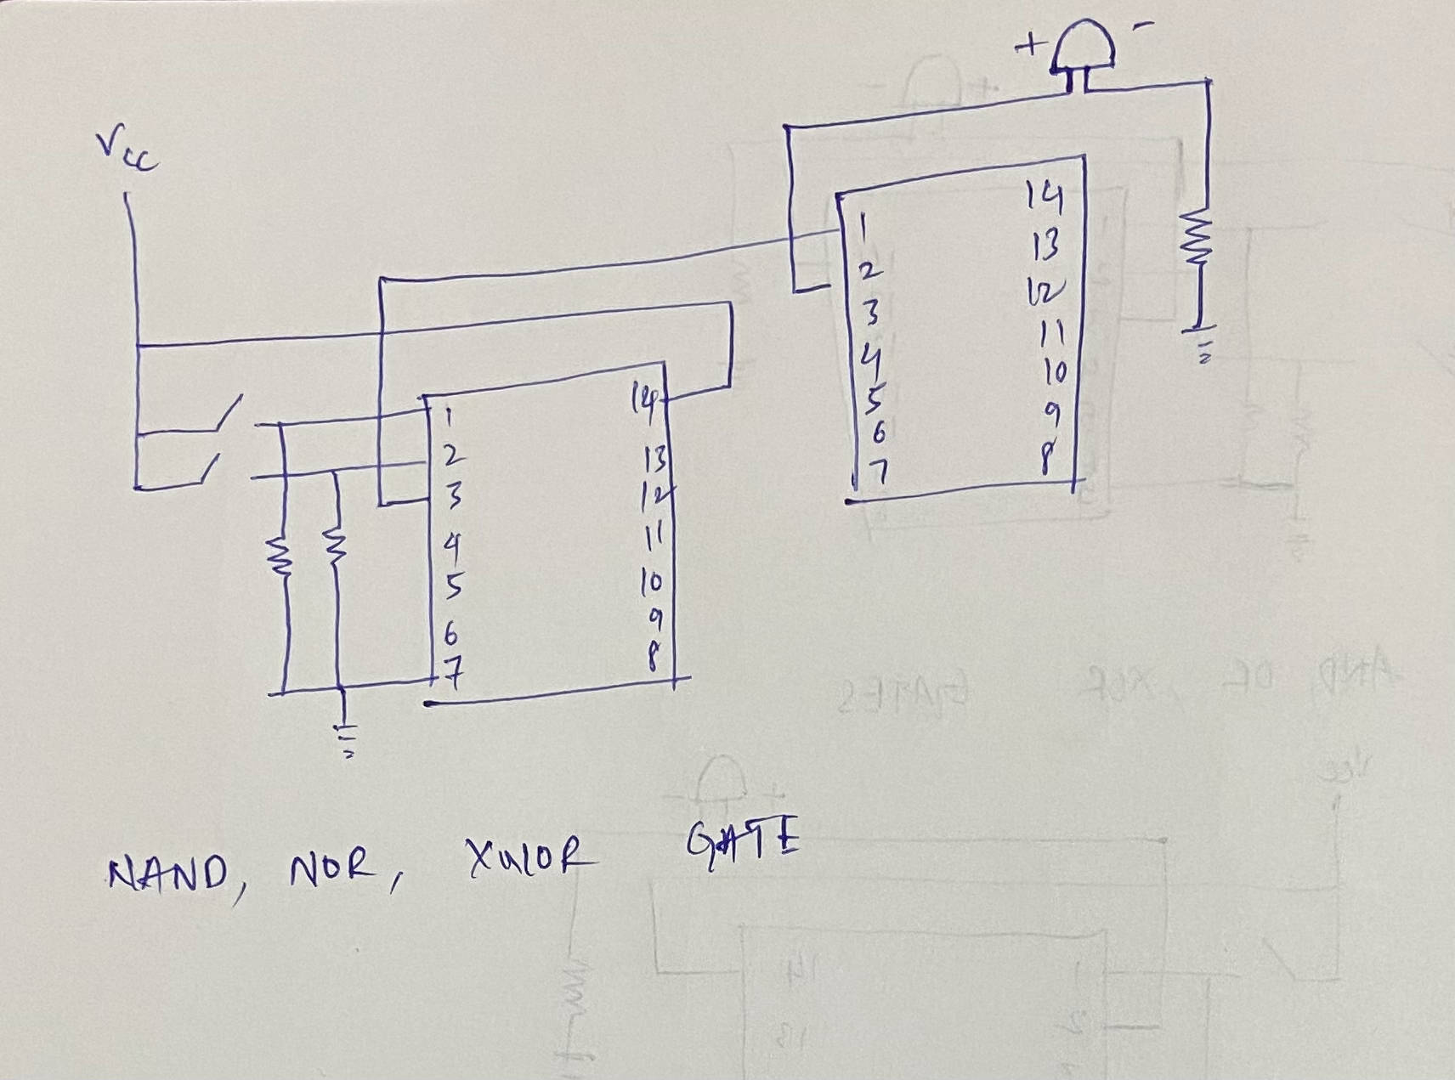

Circuit Snapshots:
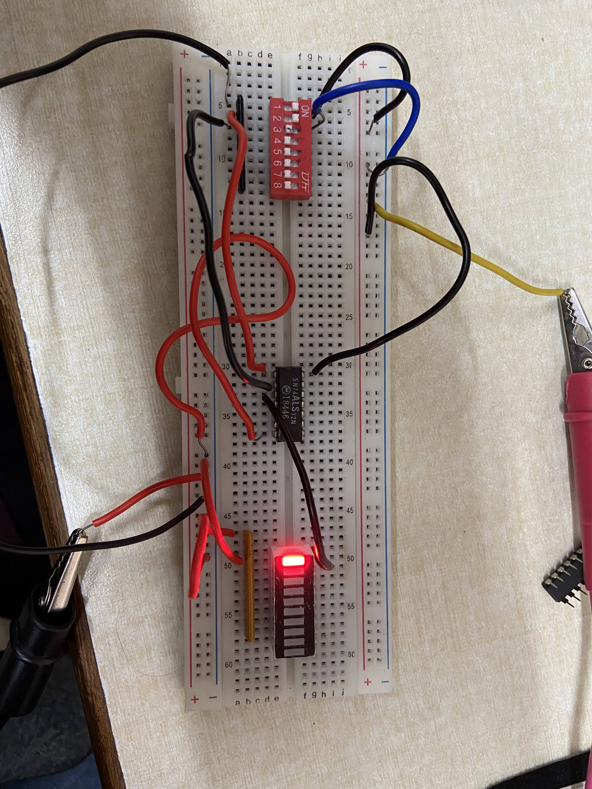
- AND GATE:

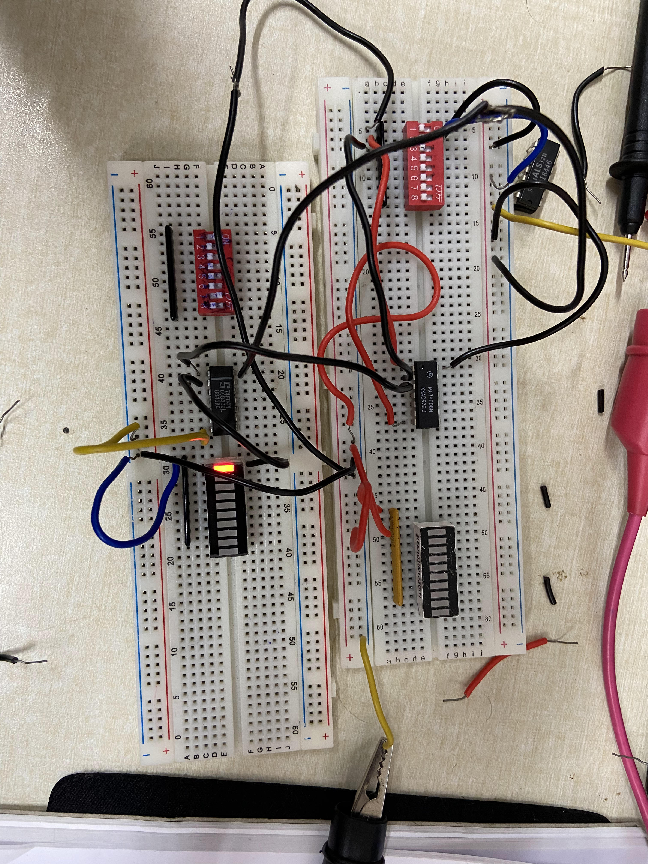
- NAND GATE:

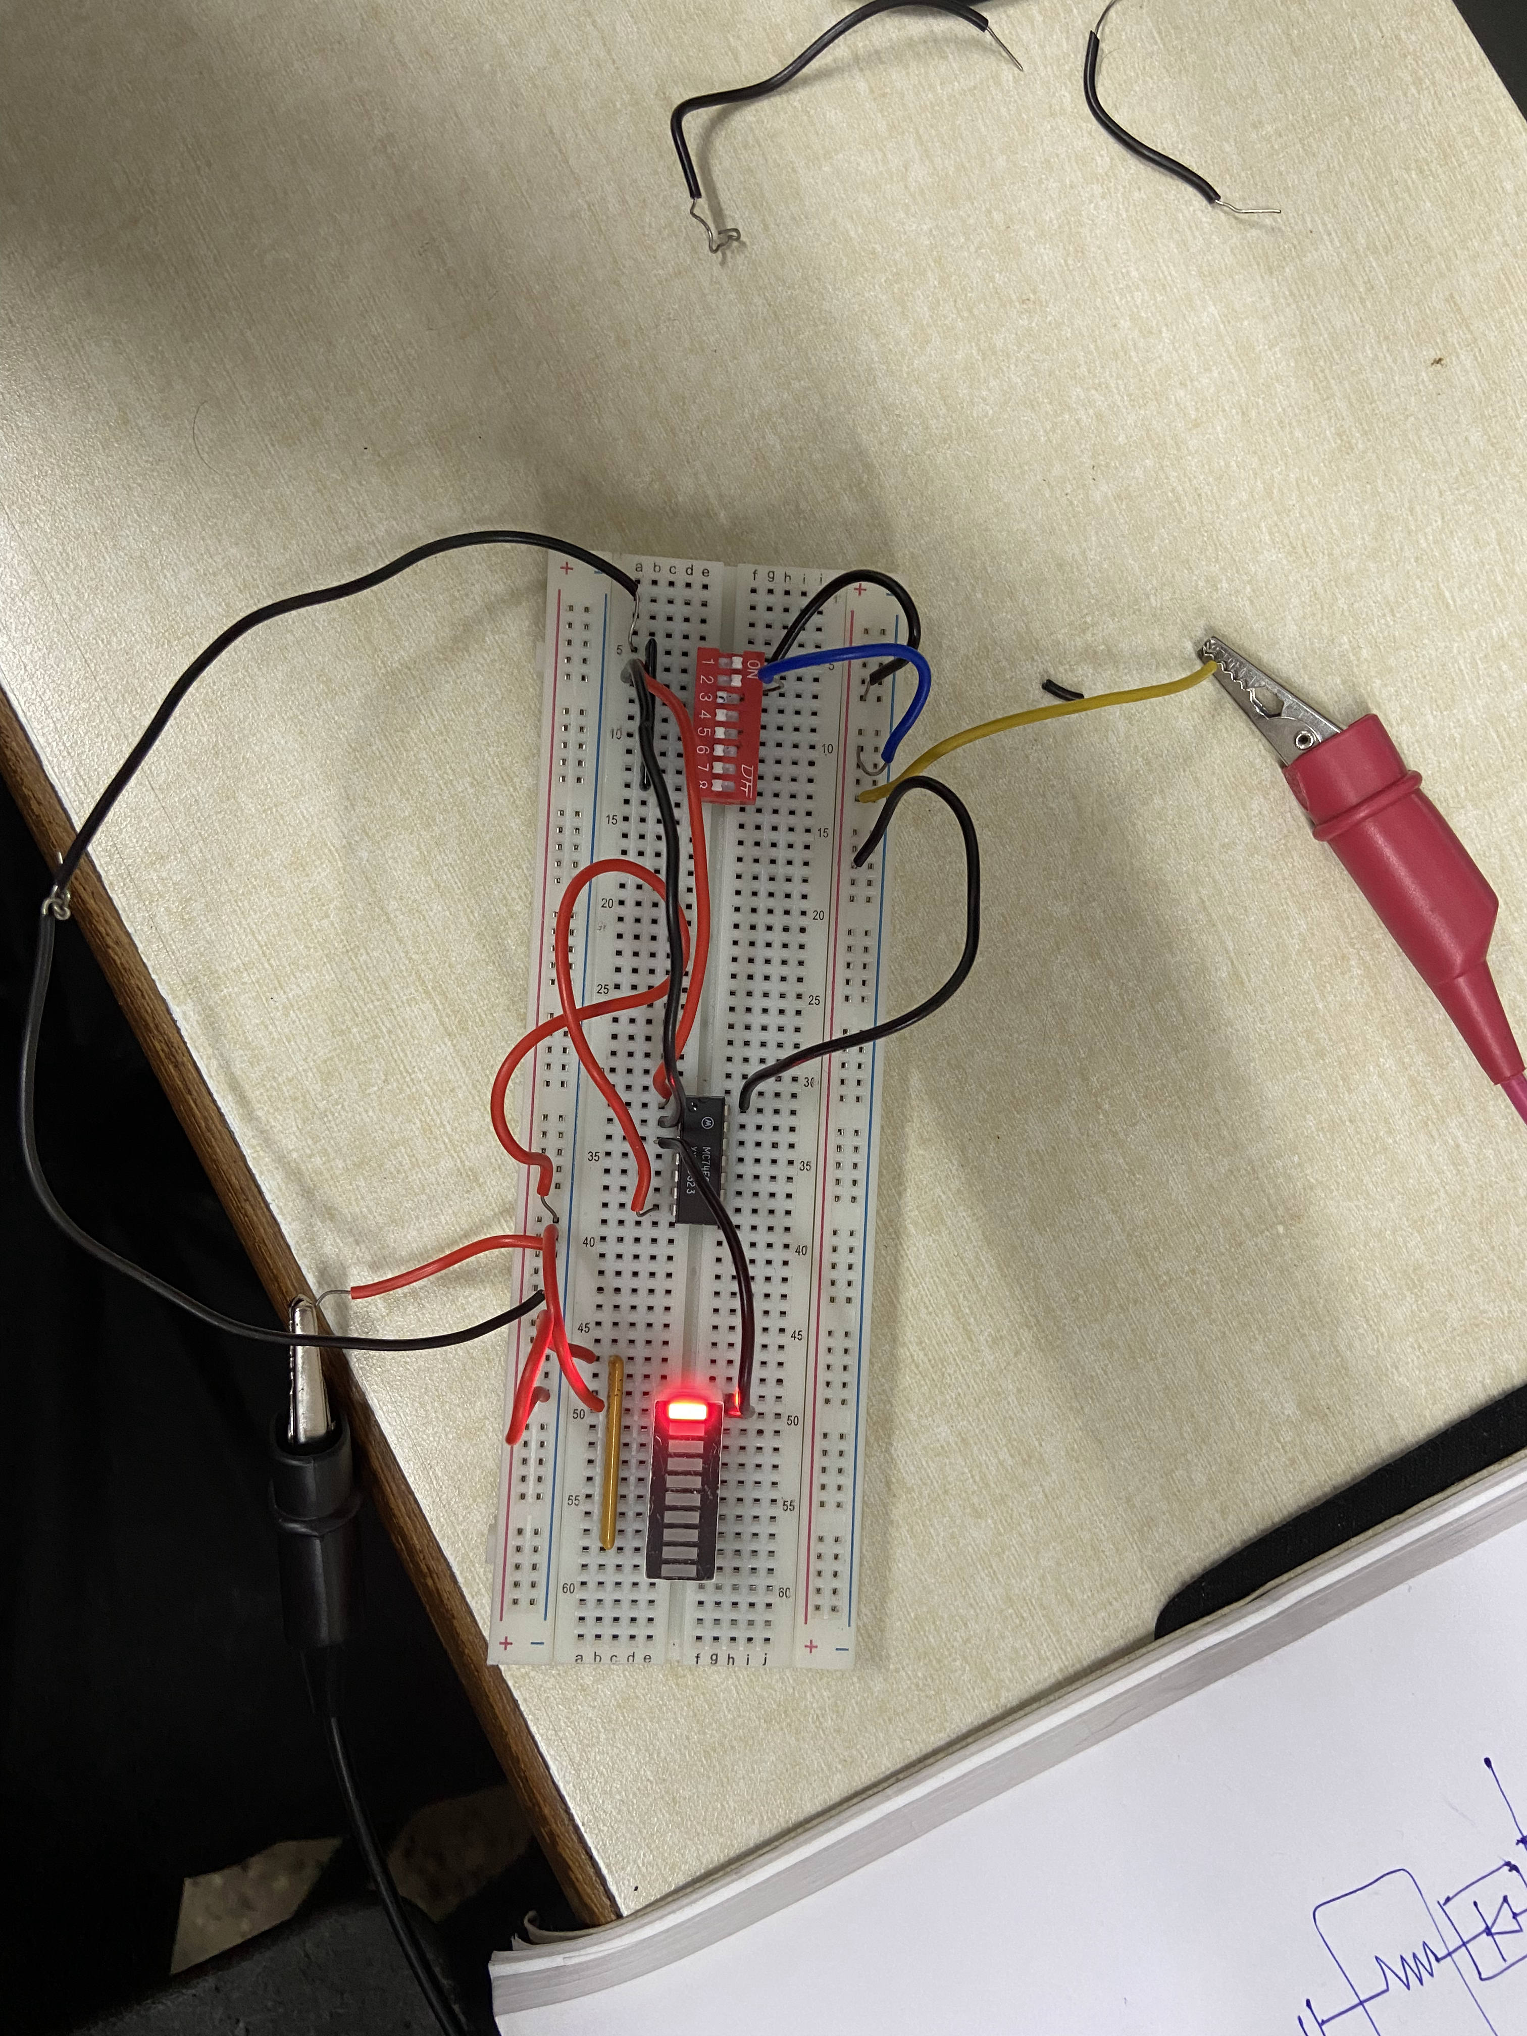
- OR GATE:

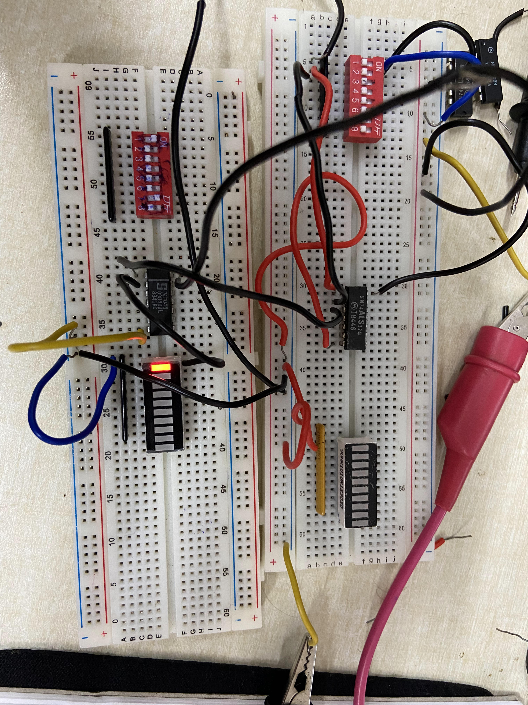
- NOR GATE

- NOT GATE
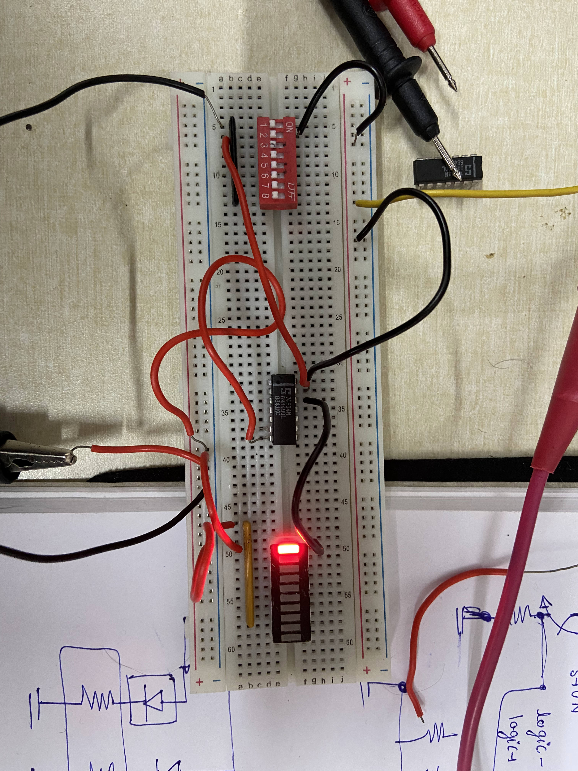

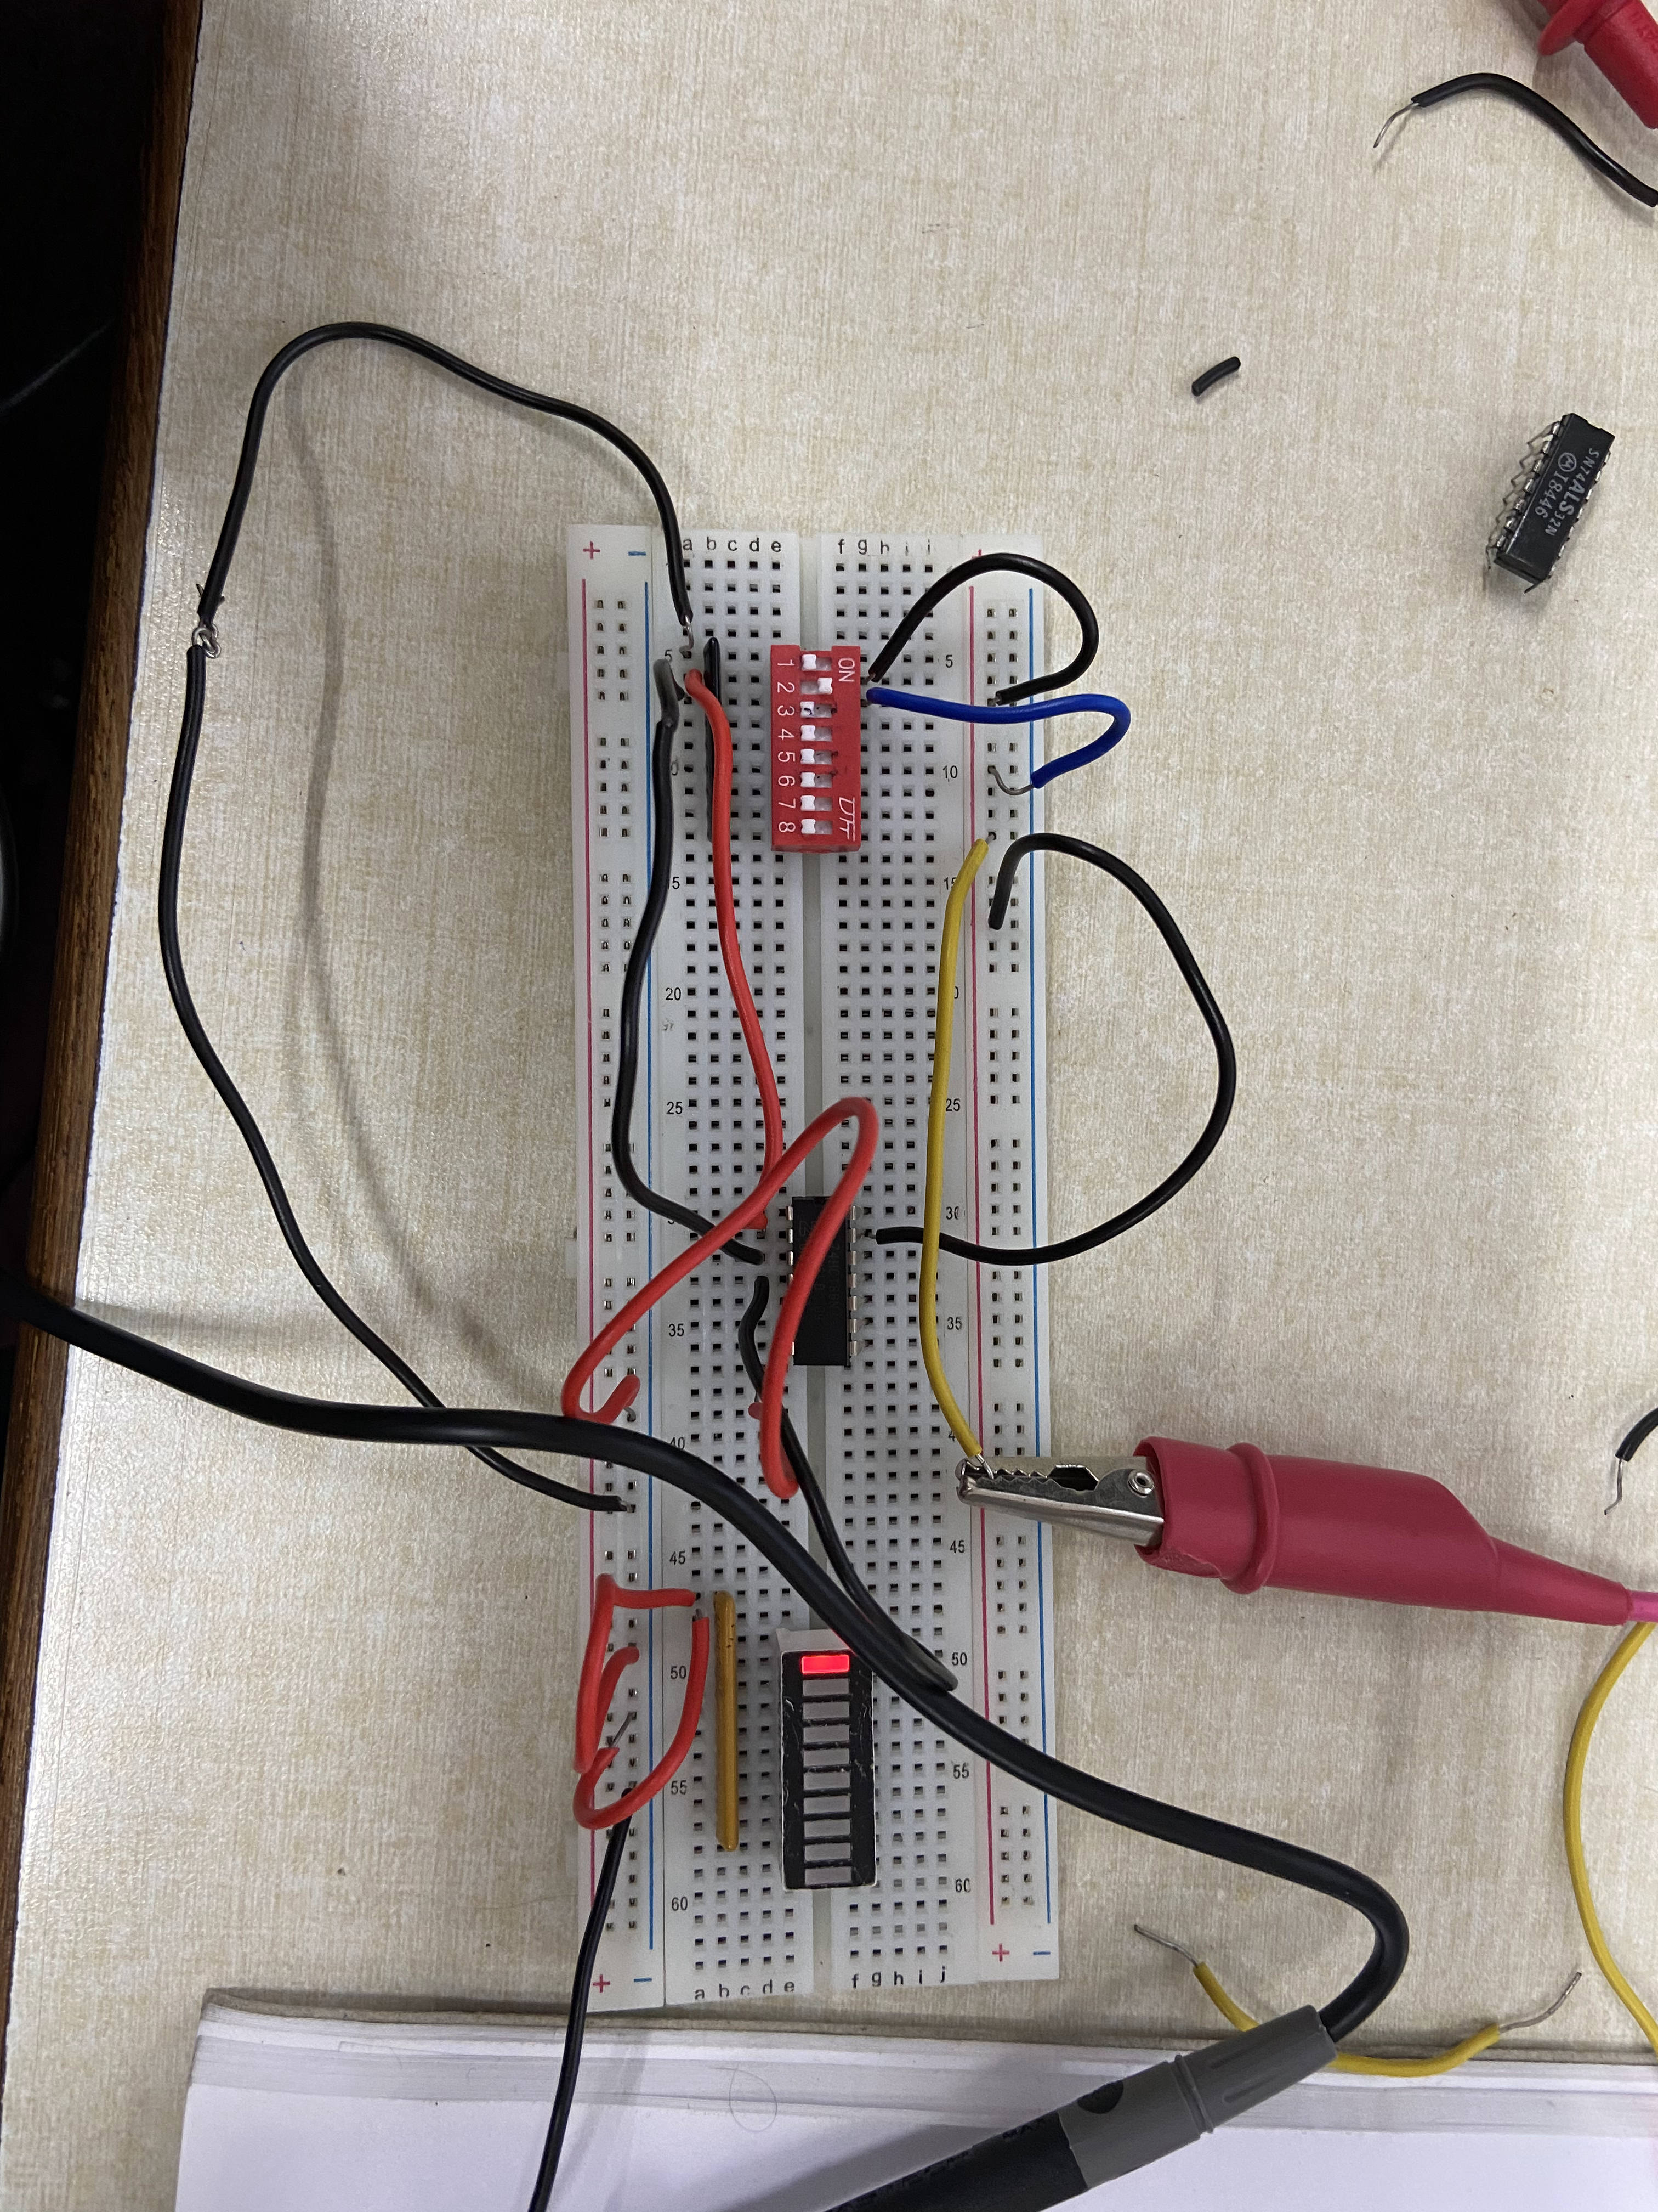
- XOR GATE

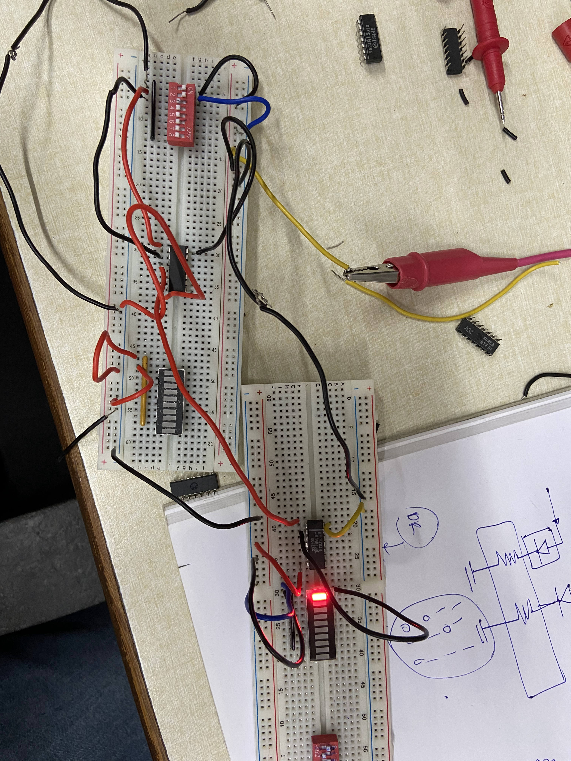
- XNOR GATE

Conclusions: We have successfully explored the workings of the basic components like power supply and have implemented the 7 logic gates using different ICs on the breadboard.

